Loan Eligibility Prediction

Abstract:

This project refers to developing an Artificial Intelligence Markup Language (AIML) based system that can predict whether a potential borrower is eligible for a loan based on their financial information.This project aims to develop a machine learning-based predictive model that determines whether a loan application should be approved or rejected based on various financial and personal attributes.

About Dataset:
Gathering relevant data points from loan applications including personal details, income sources, employment duration, credit reports, existing loans, and property ownership.The dataset used for training consists of applicant details such as income, employment status, credit history, loan amount, and dependents. After data preprocessing, feature engineering, and model training, the system is evaluated using performance metrics like accuracy, precision, recall, and F1-score. The final model aims to assist financial institutions in making data-driven lending decisions, reducing risks, and improving customer experience by automating the loan approval process.
Problem Statement:
To predict whether a potential borrower is eligible for a loan—
This can be achieved by two methods:

- Creation of a Loan Eligibility Index by deriving signals from available attributes (such as income, employment history, credit score, and existing loans) to compute a score indicating the borrower's financial credibility.
  - Key signals can include debt-to-income ratio, length of employment, number of active loans, and credit utilization.

- Machine learning algorithms are used to classify applicants based on past loan application data, identifying patterns that indicate high-risk borrowers.
  - Techniques such as decision trees, logistic regression, or neural networks can be applied for prediction.

Flowchart:

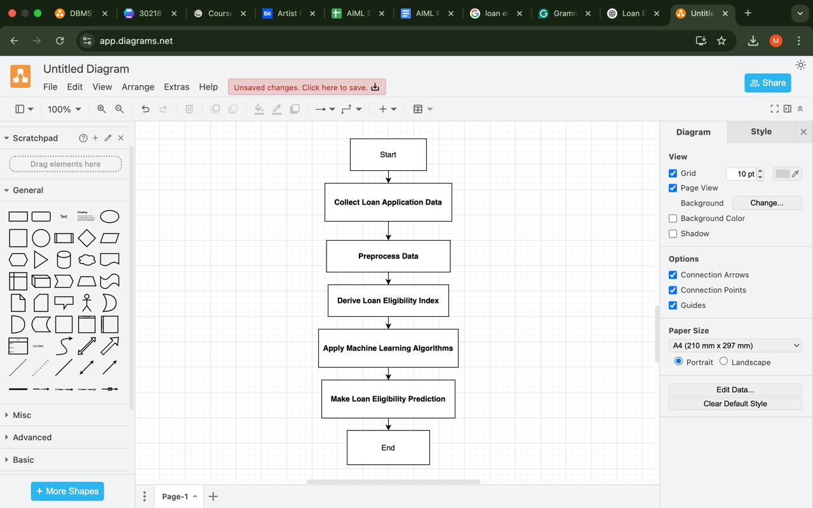

TEAM MEMBERS: -
2320030089:- ABHIGNA
2320030304:- SANTHOSHINI
2320030218:- MAHALAKSHMI

Loan Eligibility Prediction

RESULT 3
RESULT 2
RESULT 1
TEAM MEMBERS

Client Photo
SANTHOSHINI
MAHALAKSHMI

ABHIGNA
Project description
Loan eligibility prediction is a crucial aspect of the banking and financial industry. Traditional loan approval processes involve manual verification of documents, financial history, and credit scores, which can be time-consuming and prone to human errors. AI-powered loan eligibility prediction streamlines this process by leveraging machine learning models to evaluate applicants' eligibility based on various financial and demographic factors.

